1. **Create a Simple Webpage:** Create a webpage with a title “My First Webpage” that includes a header, paragraph, and an image. The image should be centered, and the header should be in bold.

<body>

    <center>

    <h1>My first webpage</h1>

    <p>Helllo</p>

    <img src="https://static.whatsapp.net/rsrc.php/v3/y6/r/wa669aeJeom.png" alt="whatsapp"></center>

</body>

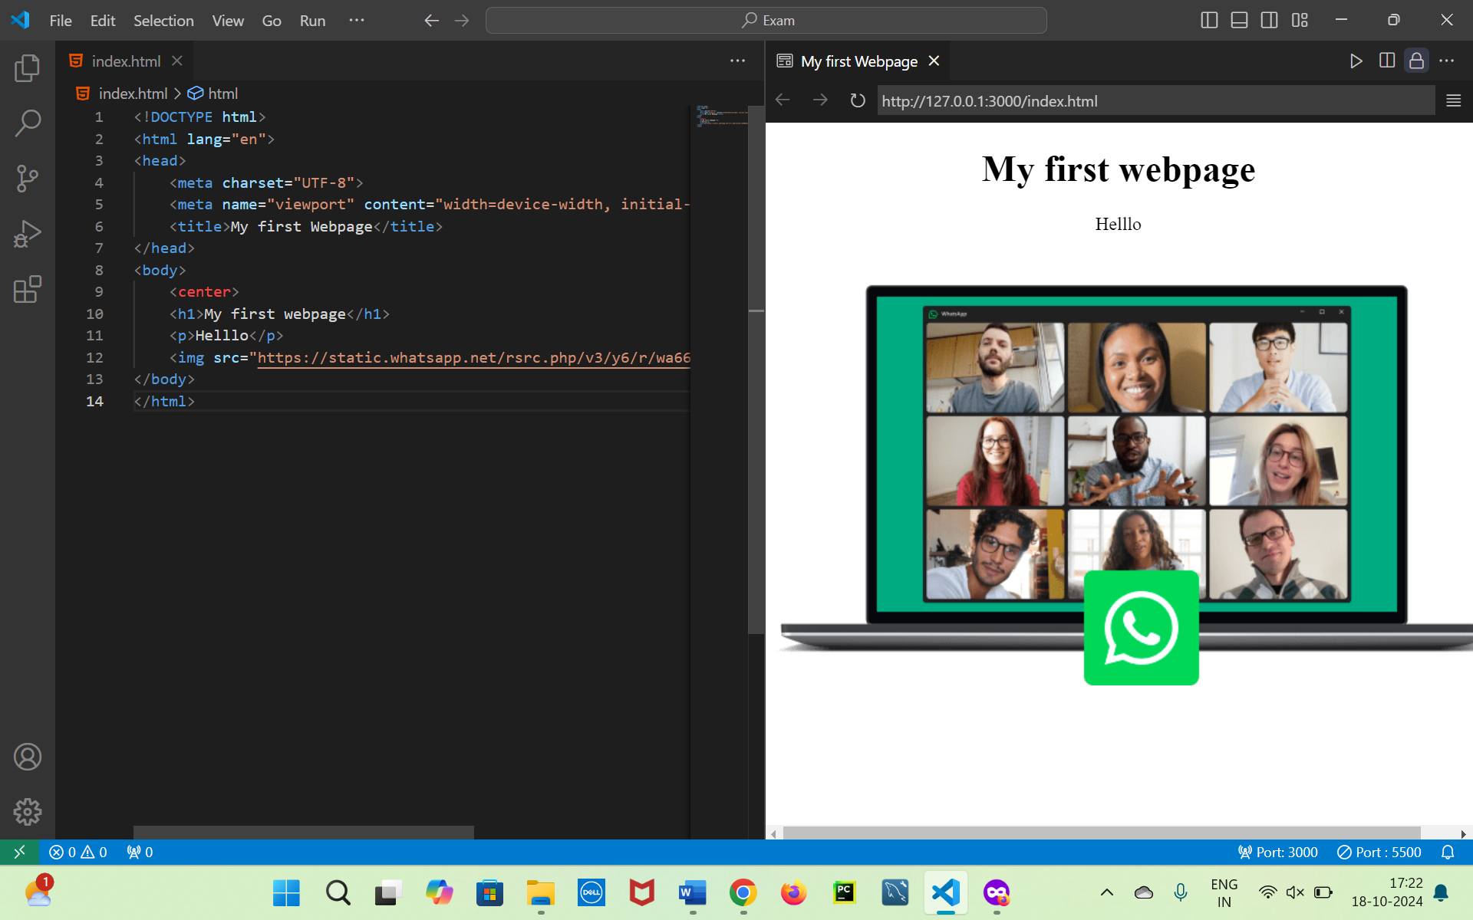

1. **Hyperlink Creation:** Create a navigation menu with three links: “Home”, “About Us”, and “Contact Us”. The “Home” link should open a new page, the “About Us” link should scroll to a section within the same page, and the “Contact Us” link should open the mail client.

<body>

<a href="./index.html" target="_blank">Home</a>

<a href="#">About us</a>

<a href="mailto:pavanummagani17@gmail.com">Contact us</a>

</body>

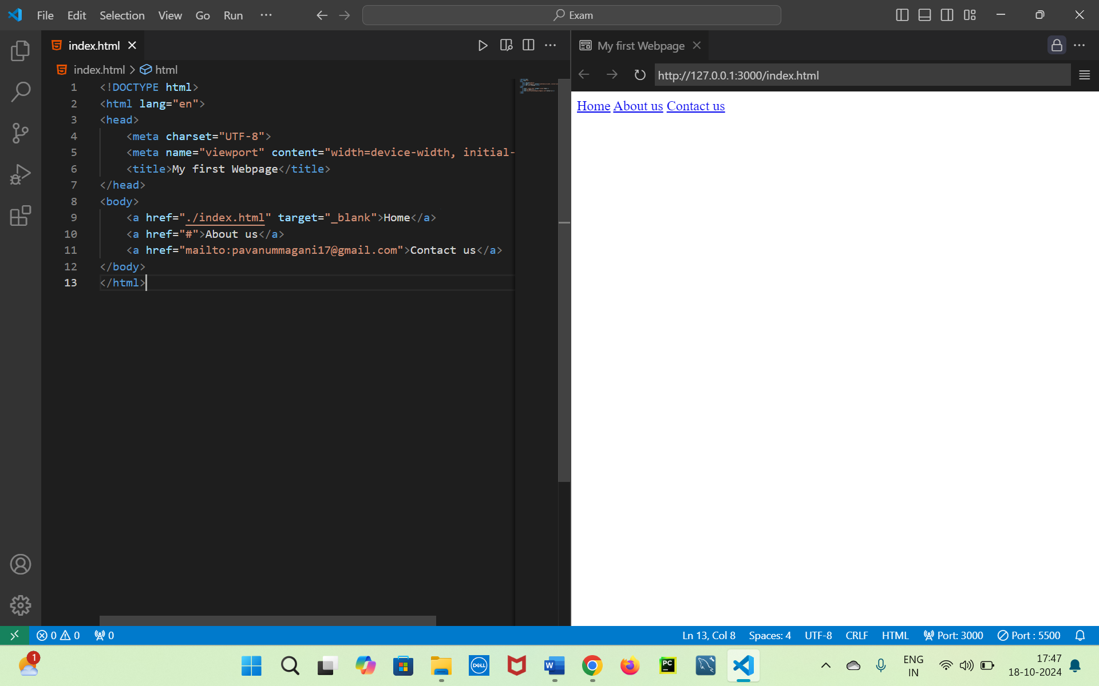

1. **Form Design:** Create a form with the following fields:
   * Name (Text Input)
   * Email (Email Input)
   * Password (Password Input)
   * Gender (Radio Buttons)
   * Hobbies (Checkboxes)
   * Submit Button

* Validate the email and password fields.

**<form action="./submit.html" method="get">**

**<!-- Text -->**

**<label for="username">User Name</label> <br>**

**<input type="text" id="username" name="Username" pattern="[a-zA-z0-9$@!&]{8,12}" title="Enter a username of length 8-12 characters" required disabled><br>**

**<br>**

**<!-- Email -->**

**<label for="email">Email</label> <br>**

**<input type="text" id="email" name="Email" pattern="[a-zA-z\d]+@(gmail|outlook|dev|gov).(com|in)" title="Enter the mail in requested format" required> <br>**

**<br>**

**<!-- Password -->**

**<label for="password">Password</label><br>**

**<input type="text" name="Password" id="password" pattern="(?=.*[A-Z])(?=.*[a-z])(?=.*[0-9])(?=.*[@$&!?]){8,12}" title="Enter the password in correct format" required>**

**<br>**

**<!-- Gender -->**

**<label for="gender">Gender</label>**

**<br>**

**<input  name="gender" type="radio" id="male">**

**<label for="male">Male</label>**

**<input name="gender" type="radio" id="female">**

**<label for="female">Female</label>**

**<br><br>**

**<!-- Checkbox -->**

**<input type="checkbox" id="checkbox1">**

**<label for="checkbox1">checkbox1</label>**

**<input type="checkbox" id="checkbox2">**

**<label for="checkbox2">checkbox2</label>**

**<input type="checkbox" id="checkbox3">**

**<label for="checkbox3">checkbox3</label>**

**<br>**

**<input type="submit" value="Submit">**

**</form>**

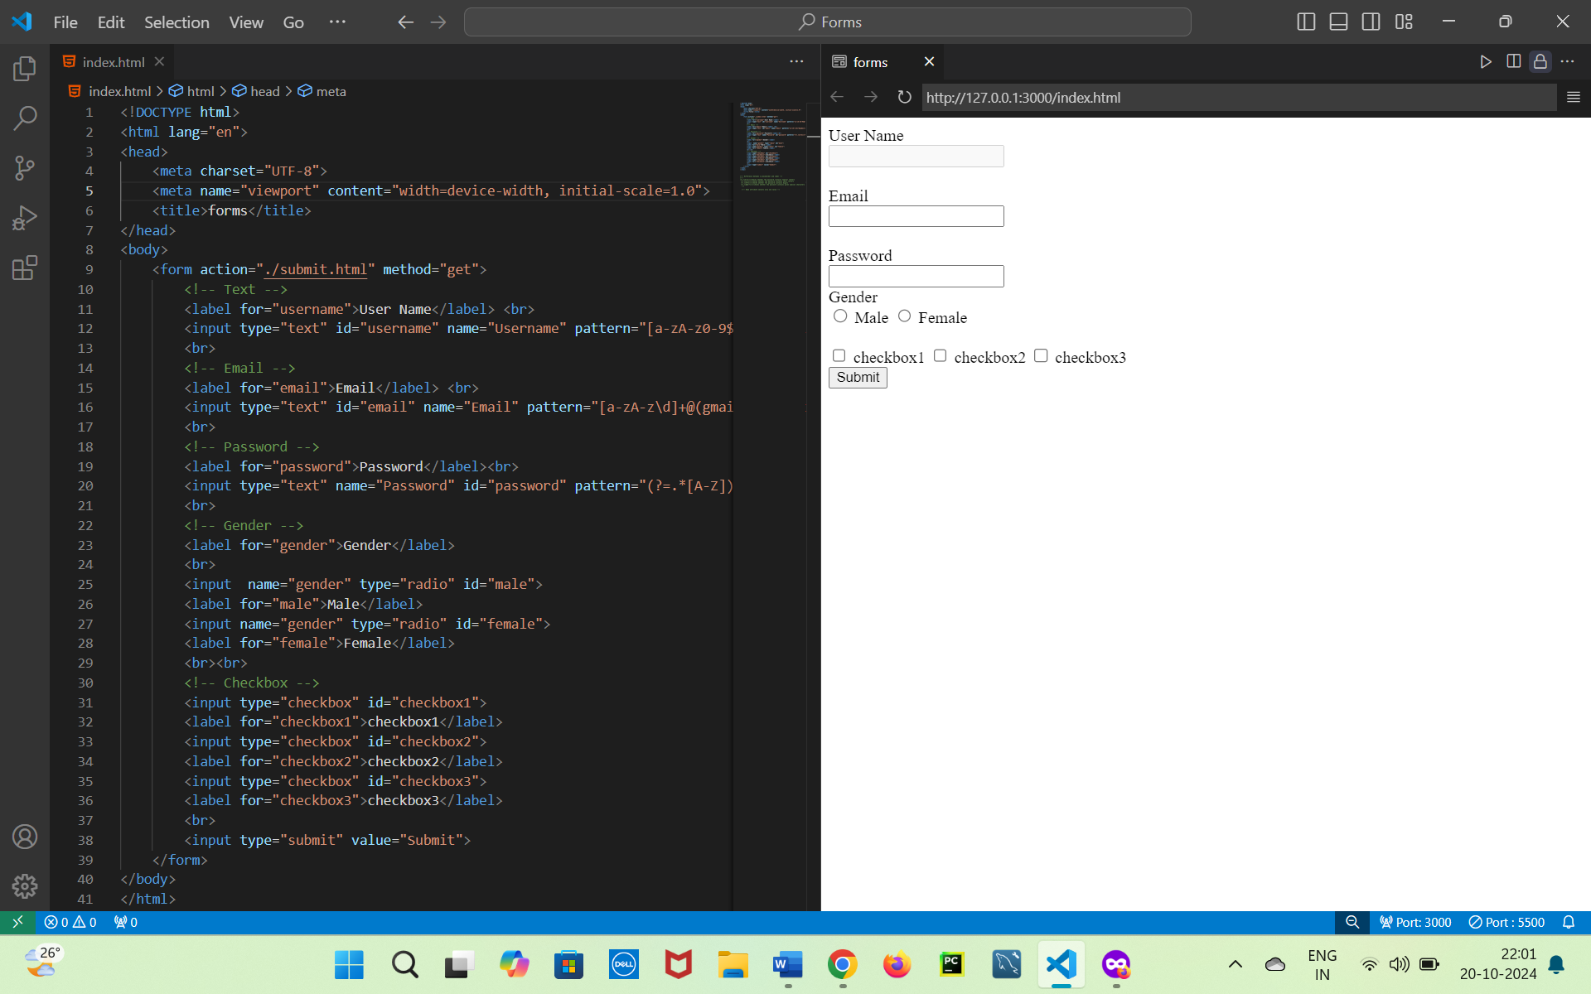

1. **Table Creation:** Create a table with 3 rows and 3 columns. The first row should be the header (containing “Name”, “Age”, and “City”). The second and third rows should contain data for two different individuals.

<body>

    <table border="2">

        <tr>

            <th>Name</th>

            <th>Age</th>

            <th>City</th>

        </tr>

        <tr>

            <th>Pavan Kalyan</th>

            <th>24</th>

            <th>Hyderabad</th>

        </tr>

        <tr>

            <th>Sanju</th>

            <th>44</th>

            <th>Mumbai</th>

        </tr>

    </table>

</body>

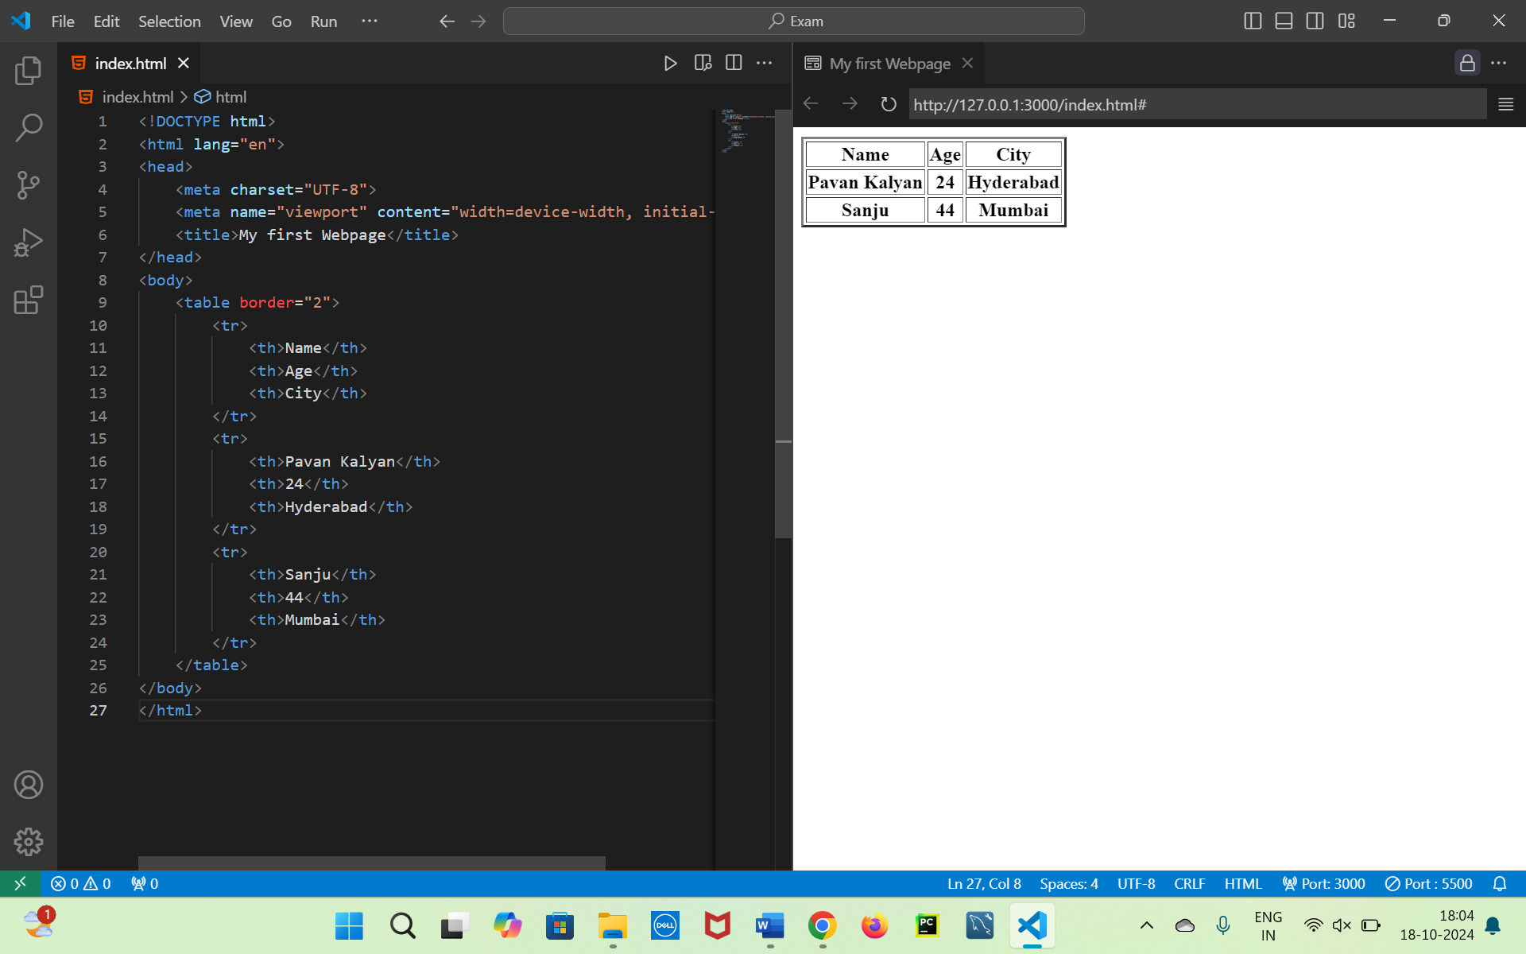

1. **Ordered and Unordered Lists:** Create two lists on a webpage:
   * An ordered list of your top 5 favorite movies.
   * An unordered list of your favorite hobbies.

    <ul>

        <li>Aakasaam Nee haddura</li>

        <li>Sanju</li>

        <li>Chichore</li>

        <li>Salaar</li>

        <li>Dasara</li>

    </ul>

    <ol>

        <li>Playing Cricket</li>

        <li>Coding</li>

        <li>Reading Books</li>

        <li>Doodling</li>

        <li>Photography</li>

    </ol>

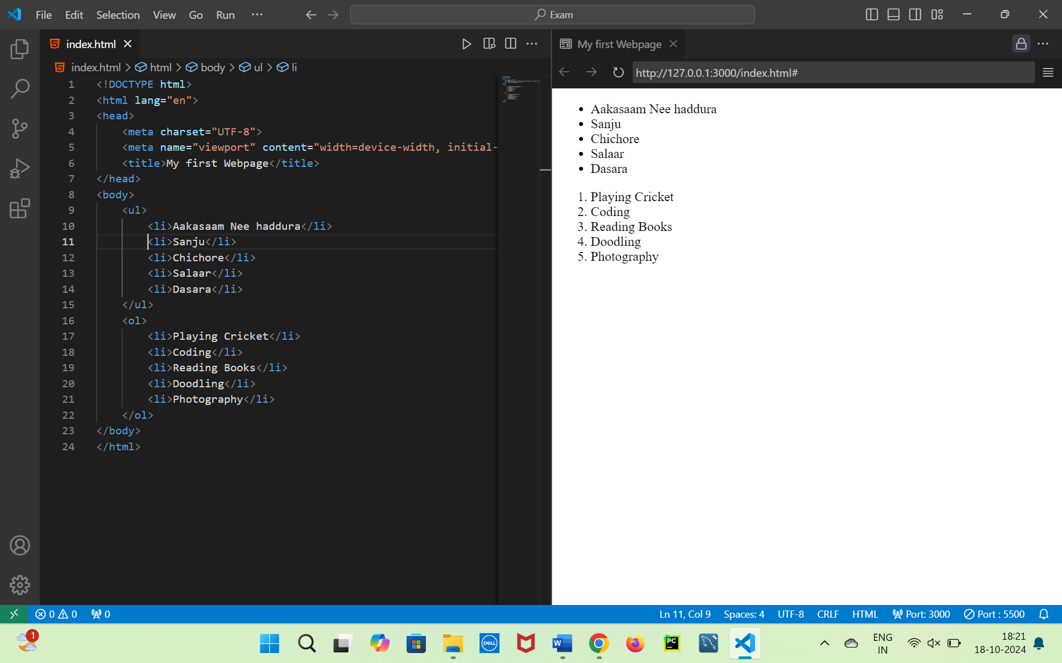

1. **Image Gallery:** Create a simple image gallery with three images arranged in a row. Each image should have a caption beneath it.

<style>

    div{

        display: flex;

    }

</style>

<body>

    <div>

        <figure>

            <img src="./iStock-1298538239.jpg" alt="" height="200px" width="200px">

            <figcaption style="text-align: center;">Globe</figcaption>

        </figure>

        <figure>

            <img src="./iStock-1298538239.jpg" alt="" height="200px" width="200px">

            <figcaption style="text-align: center;">Globe</figcaption>

        </figure>

        <figure>

            <img src="./iStock-1298538239.jpg" alt="" height="200px" width="200px">

            <figcaption style="text-align: center;"> Globe</figcaption>

        </figure>

    </div>

</body>



1. **Video and Audio Embedding:** Embed a video and an audio file on the webpage. The video should have controls for play, pause, and volume. The audio file should auto-play on page load.

<body>

<audio controls autoplay>

    <source src="./[iSongs.info] 02 - Hunter Entry.mp3">

</audio>

<video controls height="200px" width="200px">

    <source src="./videoplayback.mp4">

</video>

</body>

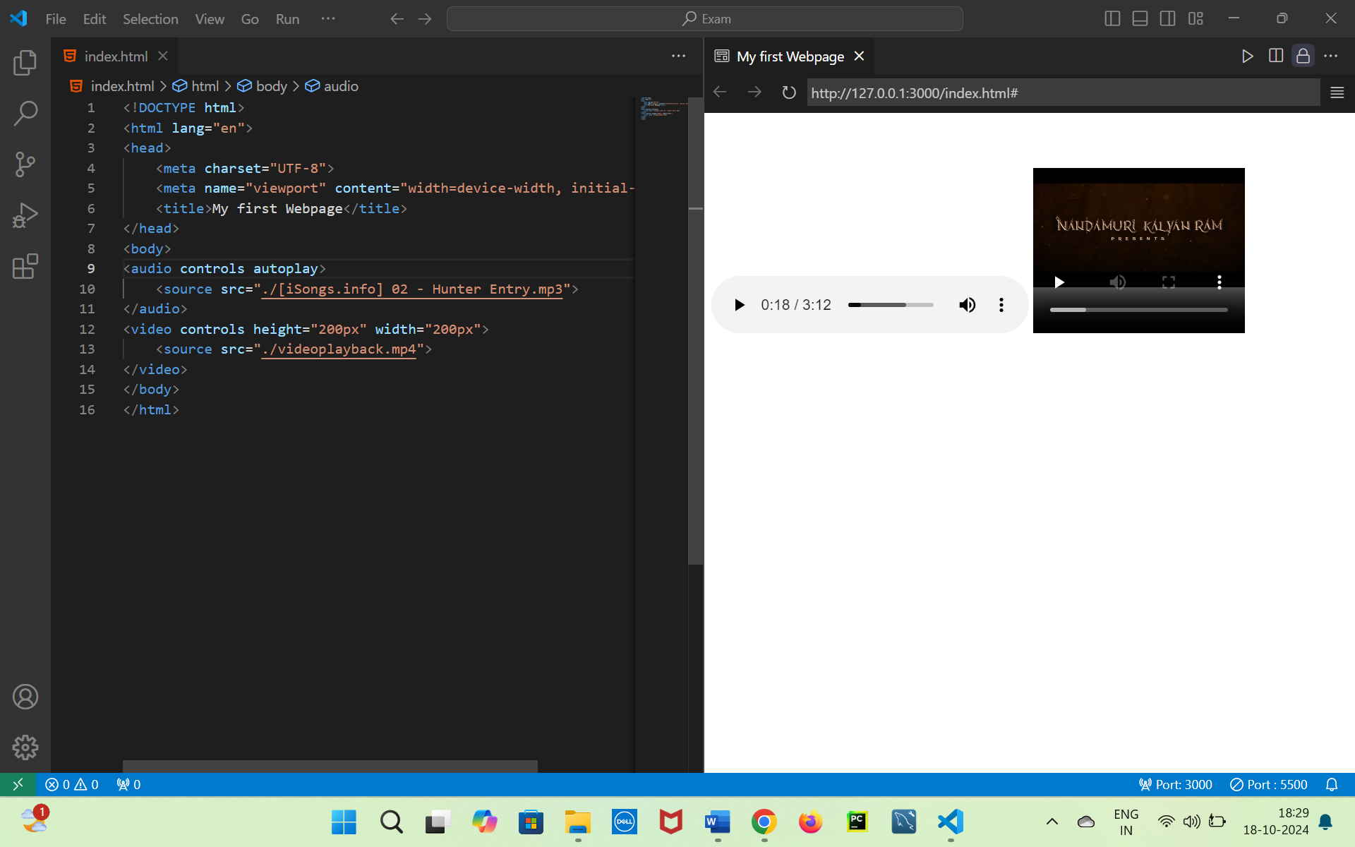

1. **Collapsible Sections:** Using <details> and <summary>, create three collapsible sections labeled “Introduction”, “Skills”, and “Projects”. Each section should contain appropriate content related to the label.

<body>

    <details>

        <summary>Introduction</summary>

        <p>lorem*4</p>

    </details>

    <details>

        <summary>Skills</summary>

        <p>lorem*4</p>

    </details>

    <details>

        <summary>Projects</summary>

        <p>lorem*4</p>

    </details>

</body>

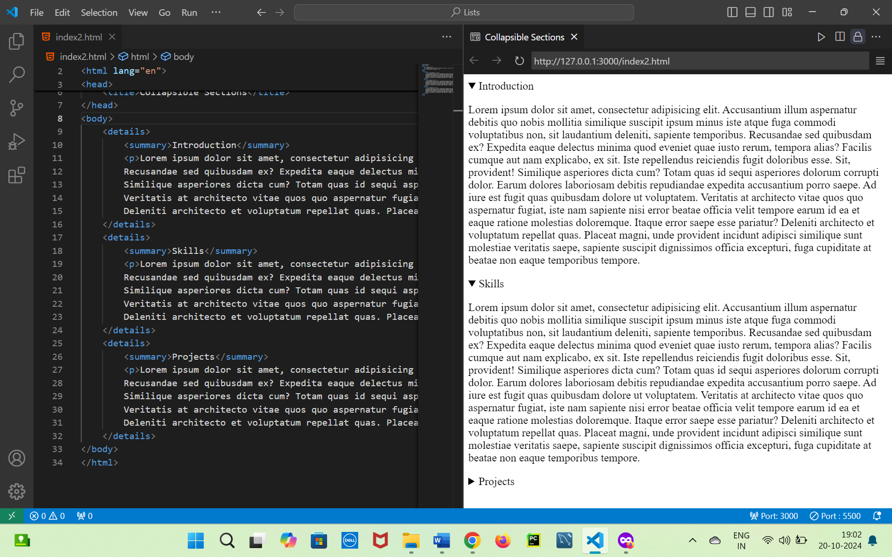

1. **Iframe Integration:** Embed a Google Map of your city’s location on the webpage using an iframe. Ensure that the iframe has a width of 600 pixels and height of 400 pixels.

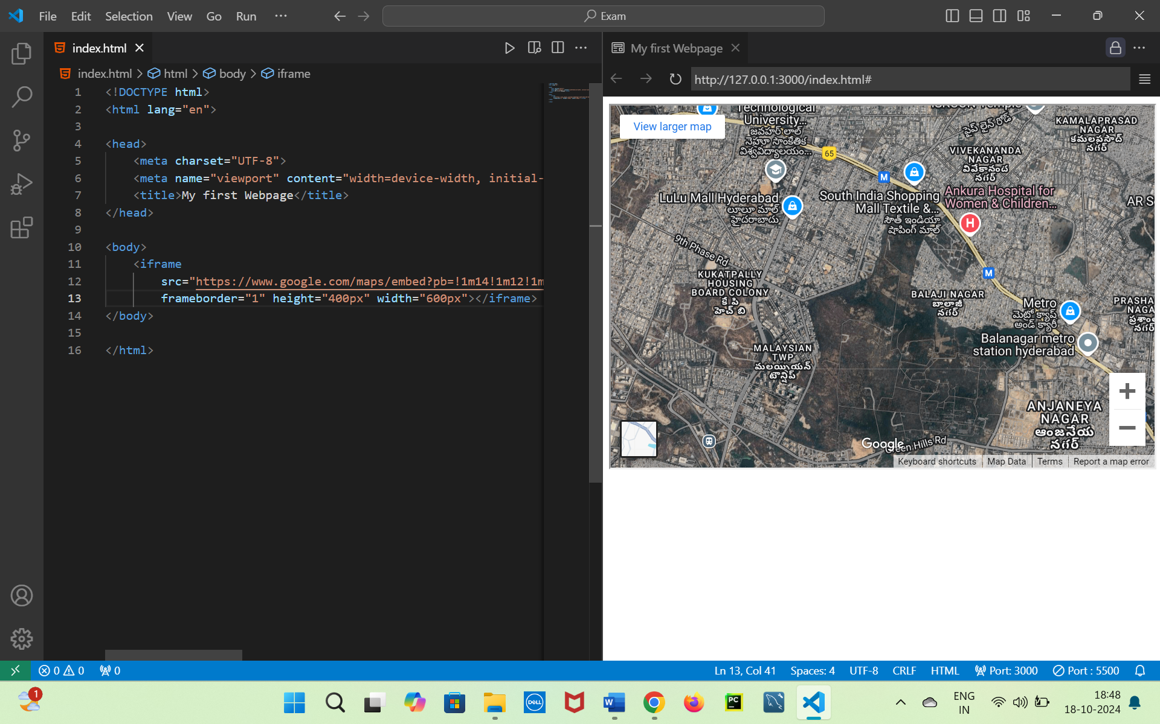

<body>

<iframe        src=”<https://www.google.com/maps/embed?pb=!1m14!1m12!1m3!1d12506.801884783934!2d78.39559795!3d17.4809431!2m3!1f0!2f0!3f0!3m2!1i1024!2i768!4f13.1!5e1!3m2!1sen!2sin!4v1729257441705!5m2!1sen!2sin>” frameborder="1" height="400px" width="600px"></iframe>

</body>

1. **HTML5 Semantic Tags:** Create a webpage using HTML5 semantic tags (<header>, <nav>, <section>, <article>, <footer>). Design a basic blog page layout using these tags with a navigation bar, main content, and a footer containing contact information.

**<body>**

**<header>**

**<nav>**

**<a href="#Home"> Home</a>**

**<a href="#About">About </a>**

**<a href="#contactus">Contact us</a>**

**</nav>**

**</header>**

**<main>**

**<section id="Home">**

**<h3>Home</h3>**

**<article>Lorem*3</article>**

**</section>**

**<section id="About">**

**<h3>About</h3>**

**<article>Lorem*3</article>**

**</section>**

**<section id="contactus">**

**<h3>Contact Us</h3>**

**<article>Lorem*3</article>**

**</section>**

**</main>**

**<footer style="text-align: center; background-color: black; color:#fff;">**

**copyright:2024@pavankalyan**

**</footer>**

**</body>**

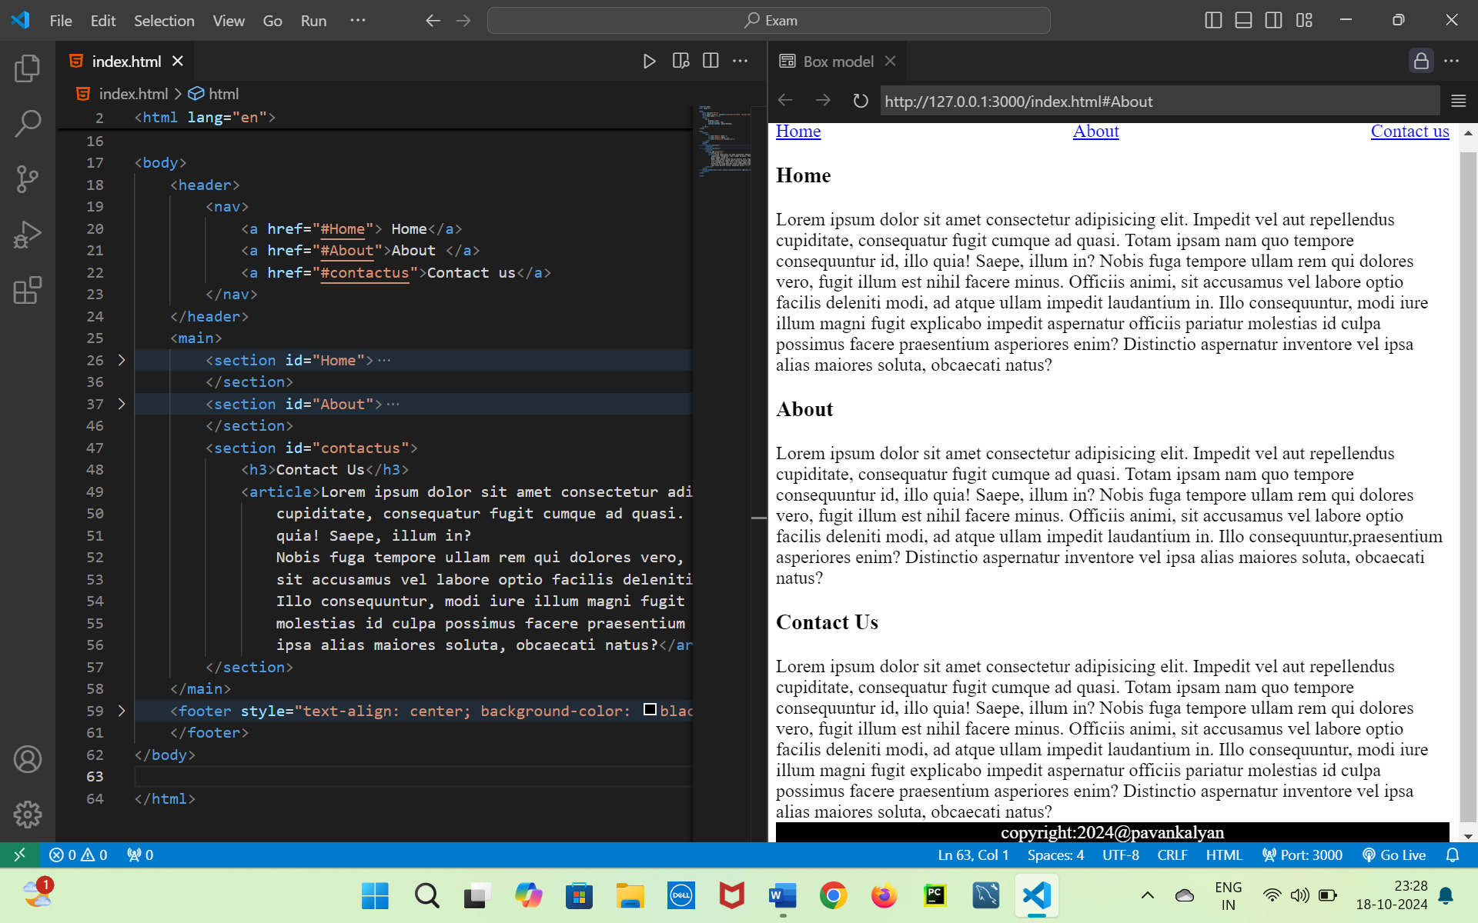

Here are the first 5 Git questions and questions 19 and 20:

1. **Git Initialization:** Create a new directory named “my_project” and initialize it as a Git repository. Add a file called index.html, stage it, and commit it with the message “Initial commit.”  
    git init

git add index.html

git commit -m “Intial Commit”

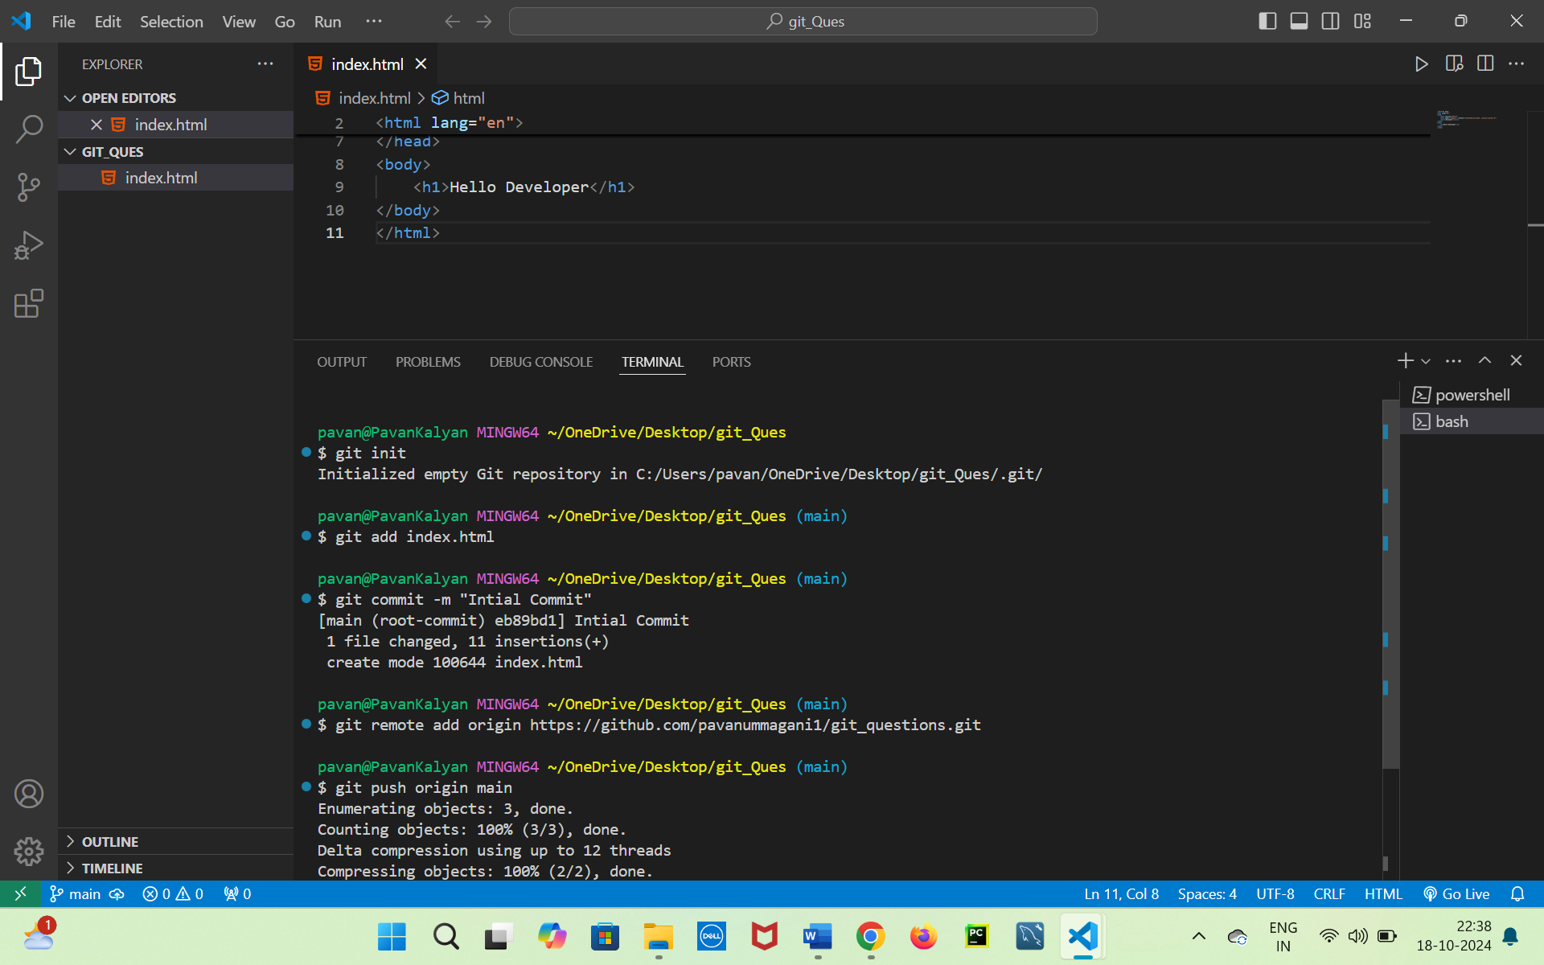

1. **Cloning a Repository:** Clone a public repository from GitHub (you can provide a sample repository URL). After cloning, display the list of branches in the repository using Git commands.
2. **git clone** [**https://github.com/pavanummagani1/branch_merge_Task_1.git**](https://github.com/pavanummagani1/branch_merge_Task_1.git)
3. **ls**
4. **cd branch_merge_Task_1**
5. **git branch**

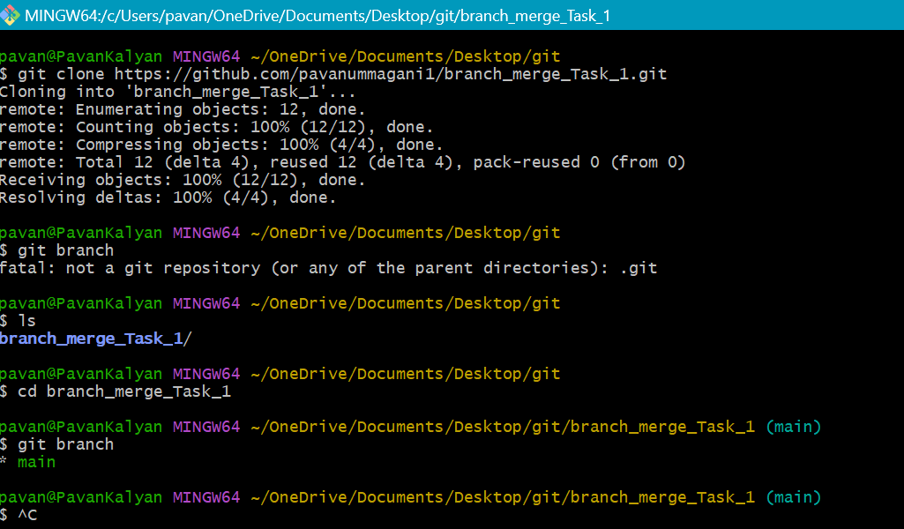

1. **Branch Creation and Checkout:** In your Git repository, create a new branch called feature-login. Switch to this branch, create a file login.html, and commit the file to the feature-login branch with a relevant commit message.

git branch feature-login

git branch

git switch feature-login

touch index1.html 🡺 creates a new file called index1.html

ls 🡺 shows the files in the folder

git add index1.html

git commit -m “feature-login”

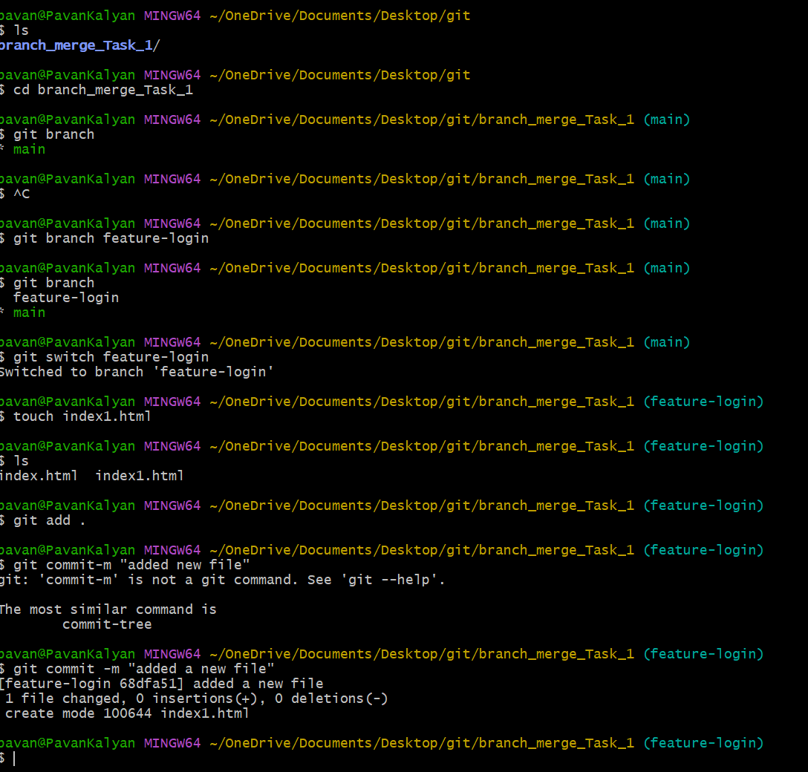

1. **Merging Branches:** Merge the changes from the feature-login branch into the main branch. Before merging, ensure you are on the main branch. Handle any potential merge conflicts, and commit the merge.

git clone <https://github.com/pavanummagani1/branch_merge_T2.git>

ls

cd branch_merge_T2

git branch featureLogin

git switch featureLogin

touch index2.html

git add index2.html

git commit -m “Added a file in featureLogin branch”

git checkout main

git merge featureLogin -m “Merging featureLogin branch to main”

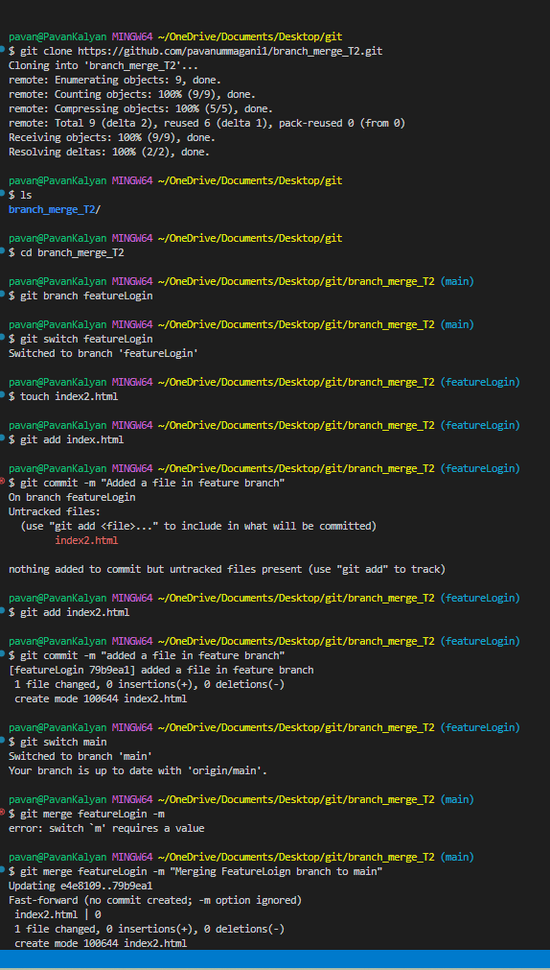

1. **Viewing Commit History:** Display the commit history of the current branch, showing only the commit messages and hash IDs in a simplified format. Then, display the commit history graphically using Git commands.

**git log - -**all 🡺Shows all the commit history

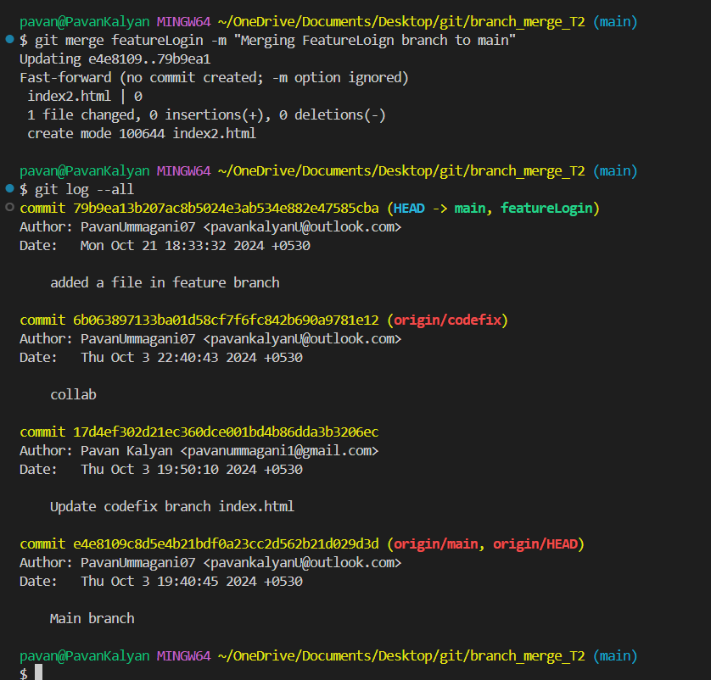

1. **Git Pull and Push:** Demonstrate how to pull the latest changes from a remote repository into your local repository. Make some changes locally, commit them, and then push the changes to the remote repository.
2. Git init
3. Git add .
4. Git commit -m “Git pull and Push Demonstartion”
5. Git remote add origin Repository URL
6. Git push origin main

Till now the code is pushed in the given Repo URL

Collabrate with anyone askthem to pull your code.

Git Pull

1. Git clone
2. Git fetch
3. Git pull
4. Add few lines or edit the pulled code
5. Git add .
6. Git commit -m “Added fewlines”
7. Git push origin main  
   If Conflicts arise accept the conflicts manually

**PUSH Demonstration**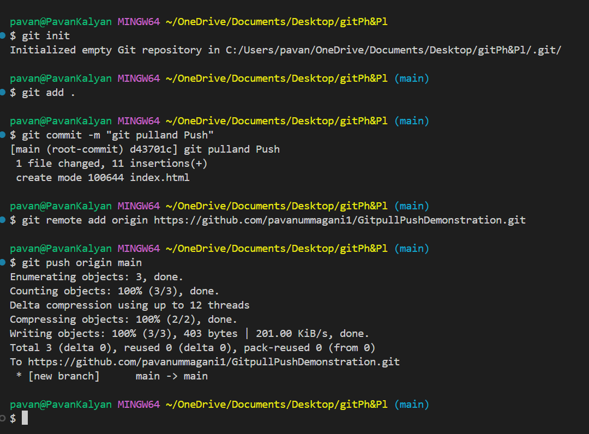

**PULL and Push Demonstration** 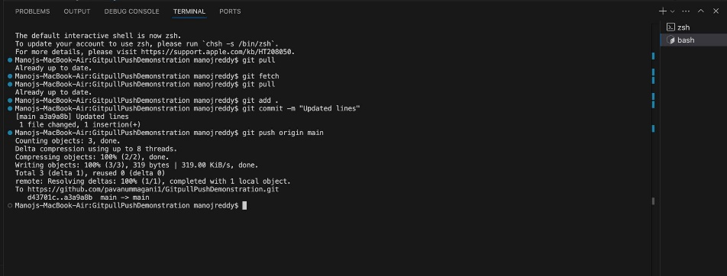

1. **Resolving Conflicts:** Simulate a merge conflict situation by modifying the same line in a file on two different branches. Show the process of resolving the conflict and committing the resolution
2. git init
3. git add .
4. git commit -m “Commit-1”
5. git branch feature1
6. git branch feature2
7. git checkout feature1 🡺 Make changes in the code
8. git switch main
9. git checkout feature2 🡺makes the changes in the same line where you made in the feature1 branch
10. git switch main
11. git merge feature1 -m “Merging f1 to main”
12. git merge feature2 -m “merging f2 to main” 🡺 you will get the conflicts as shown below

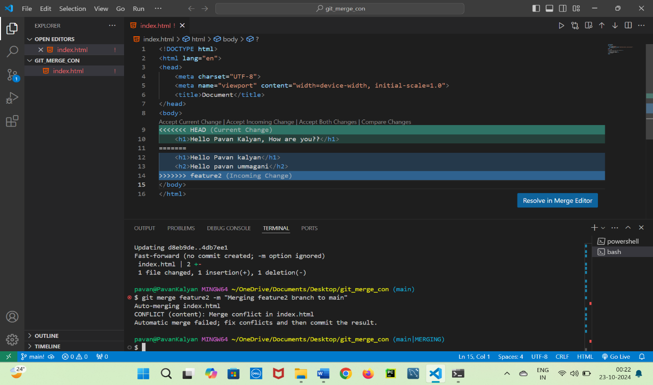

Accepts the both changes if you want, or else you can go with other options,

1. git add .
2. git commit -m “merging f2 to main”
3. git remote add origin Repository link
4. git push origin main

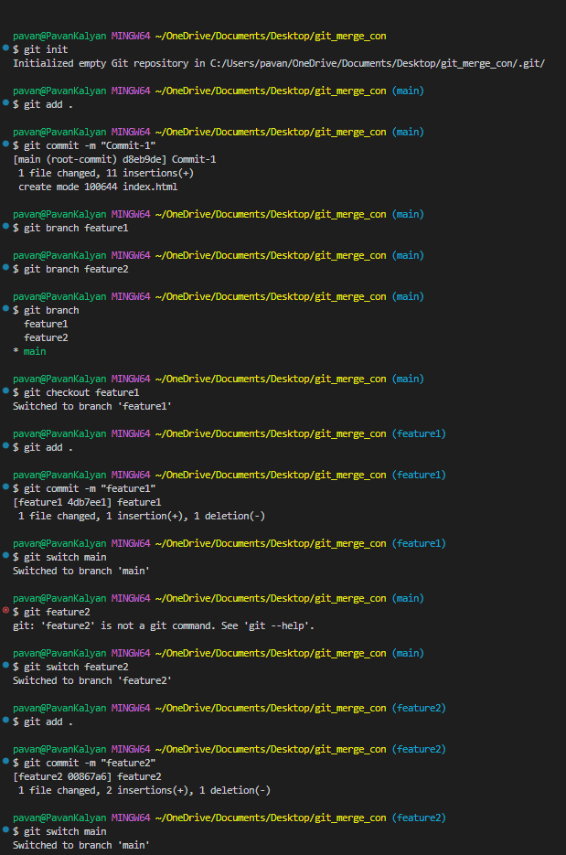

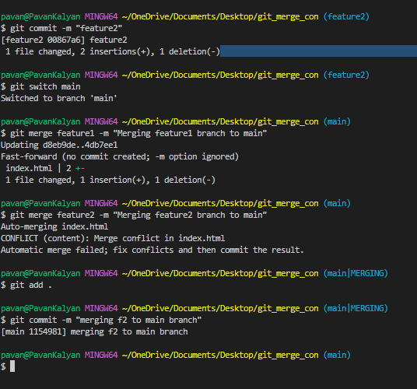

### 18. Box Model: Padding and Margin

**HTML:**

<div class="box">  
 Content inside the box  
</div>

**Question:** Write the CSS to create a box with the following: - A width of 300px and a height of 200px. - Add 20px padding inside the box. - Add a 10px margin outside the box. - Apply a solid border of 2px in blue.

<head>

    <meta charset="UTF-8">

    <meta name="viewport" content="width=device-width, initial-scale=1.0">

    <title>Box model</title>

    <style>

        *{

            margin: 0px;

            padding: 0px;

            box-sizing: border-box;

        }

        .box{

            width: 300px;

            height: 200px;

            margin: 10px;

            padding: 20px;

            border: 2px solid blue;

        }

    </style>

</head>

<body>

    <div class="box">

        Content inside the box

      </div>

</body>

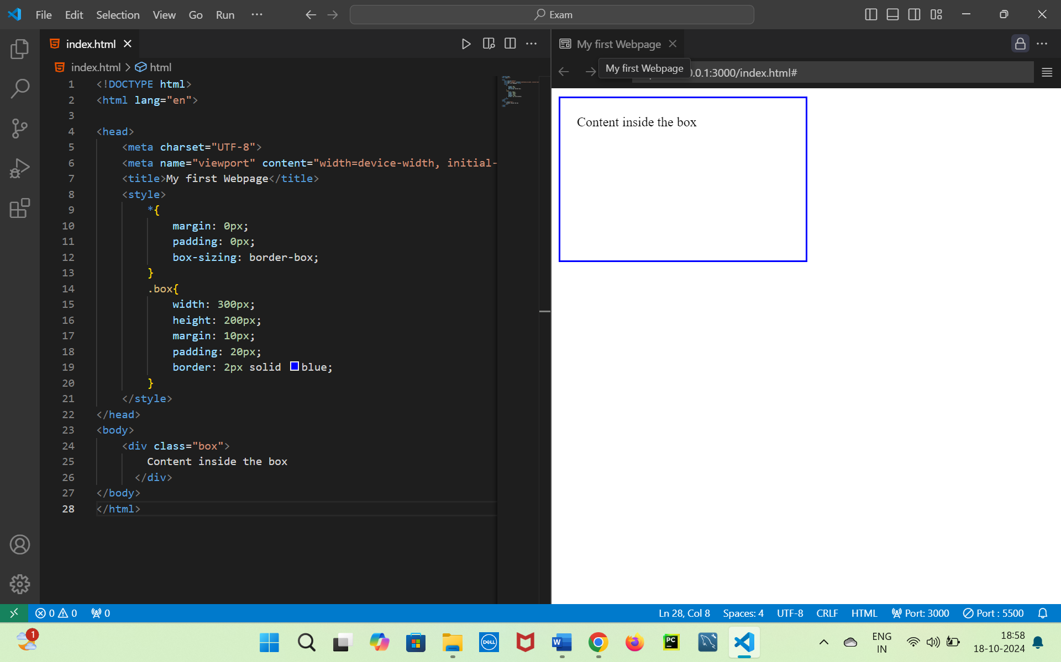

### 19. Box Model: Border and Box-Sizing

**HTML:**

<div class="container">  
 <div class="box-1">Box 1</div>  
 <div class="box-2">Box 2</div>  
</div>

**Question:** Write the CSS to: - Set the width of both boxes to 150px and height to 100px. - Add 5px solid black borders to both boxes. - Ensure that padding does not increase the size of the boxes (use box-sizing).

*{

            margin: 0px;

            padding: 0px;

            box-sizing: border-box;

        }

        .container{

            border: 2px solid;

            margin: 10px;

            padding: 10px;

        }

        .box-1, .box-2{

            height: 100px;

            width: 150px;

            border: 2px solid;

            margin: 10px;

        }

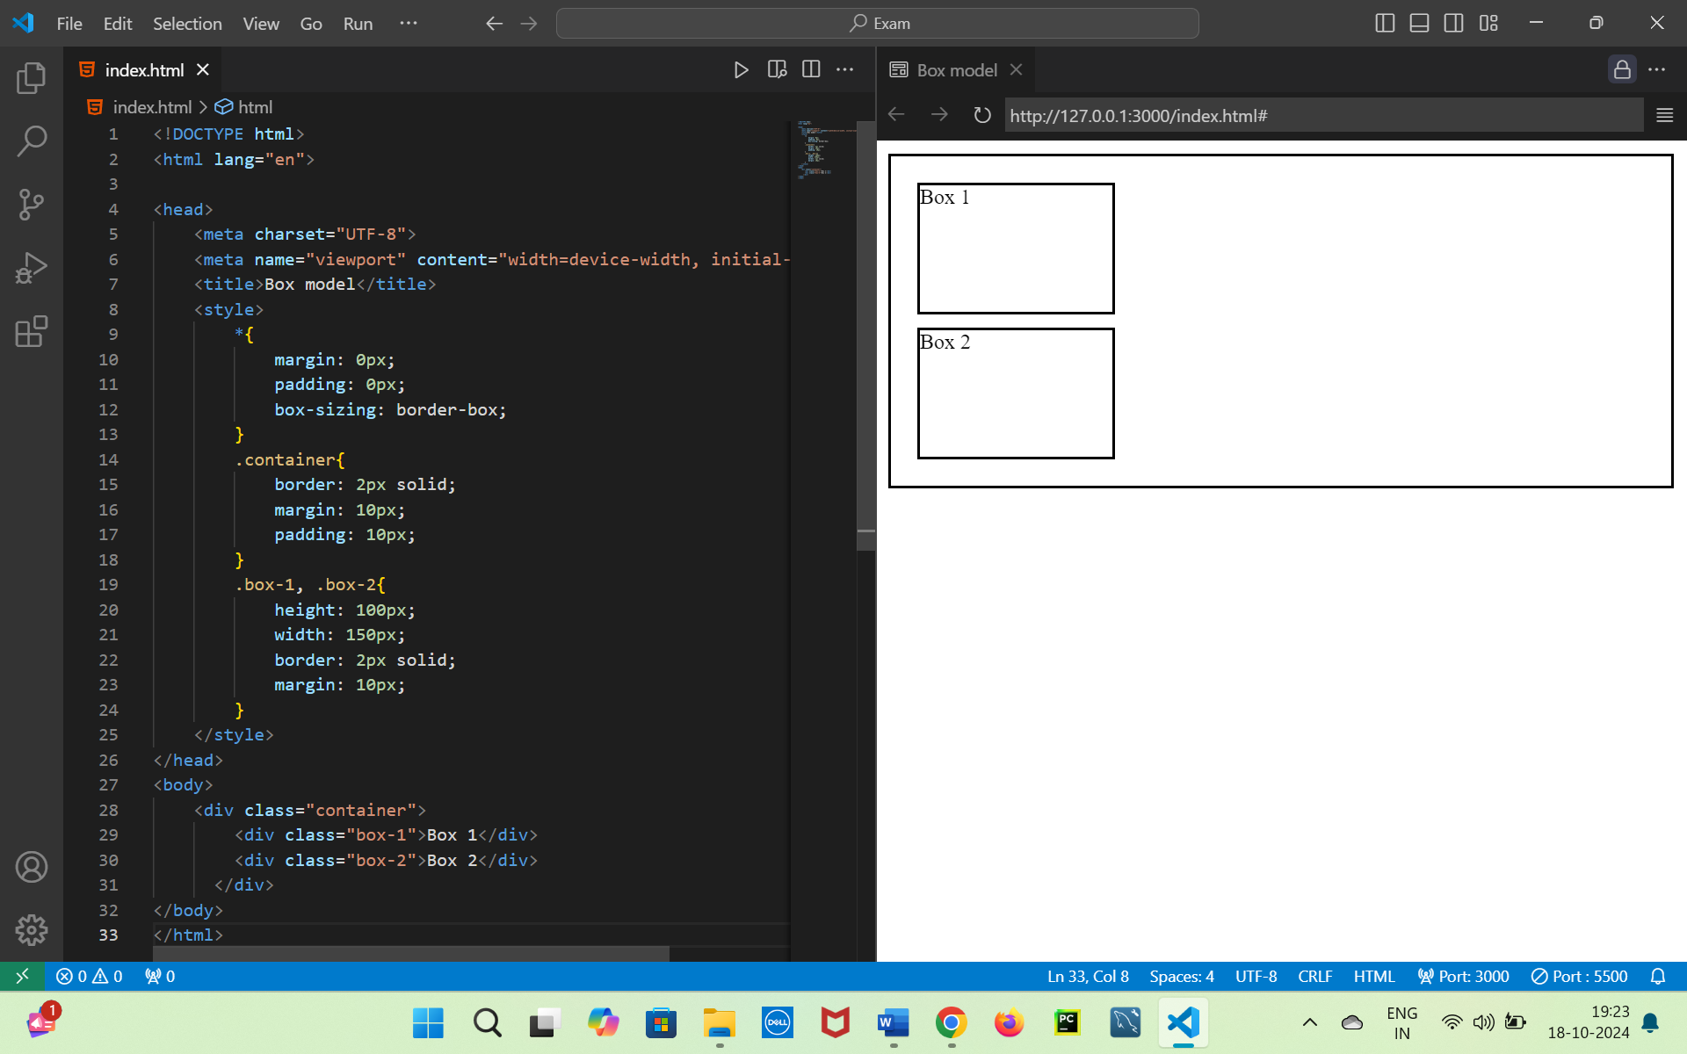

### 20. Units: Relative and Absolute Units

**HTML:**

<div class="text-container">  
 <p class="text">This is some text.</p>  
</div>

**Question:** Write the CSS to: - Set the font size of the text to 2em. - Set the width of .text-container to 50% of the viewport width. - Add 1rem padding to .text-container.

    <style>

        .text-container{

            width: 50vw;

            font-size: 2em;

            border: 2px solid;

        }

        .text{

            padding: 1em;

        }

    </style>

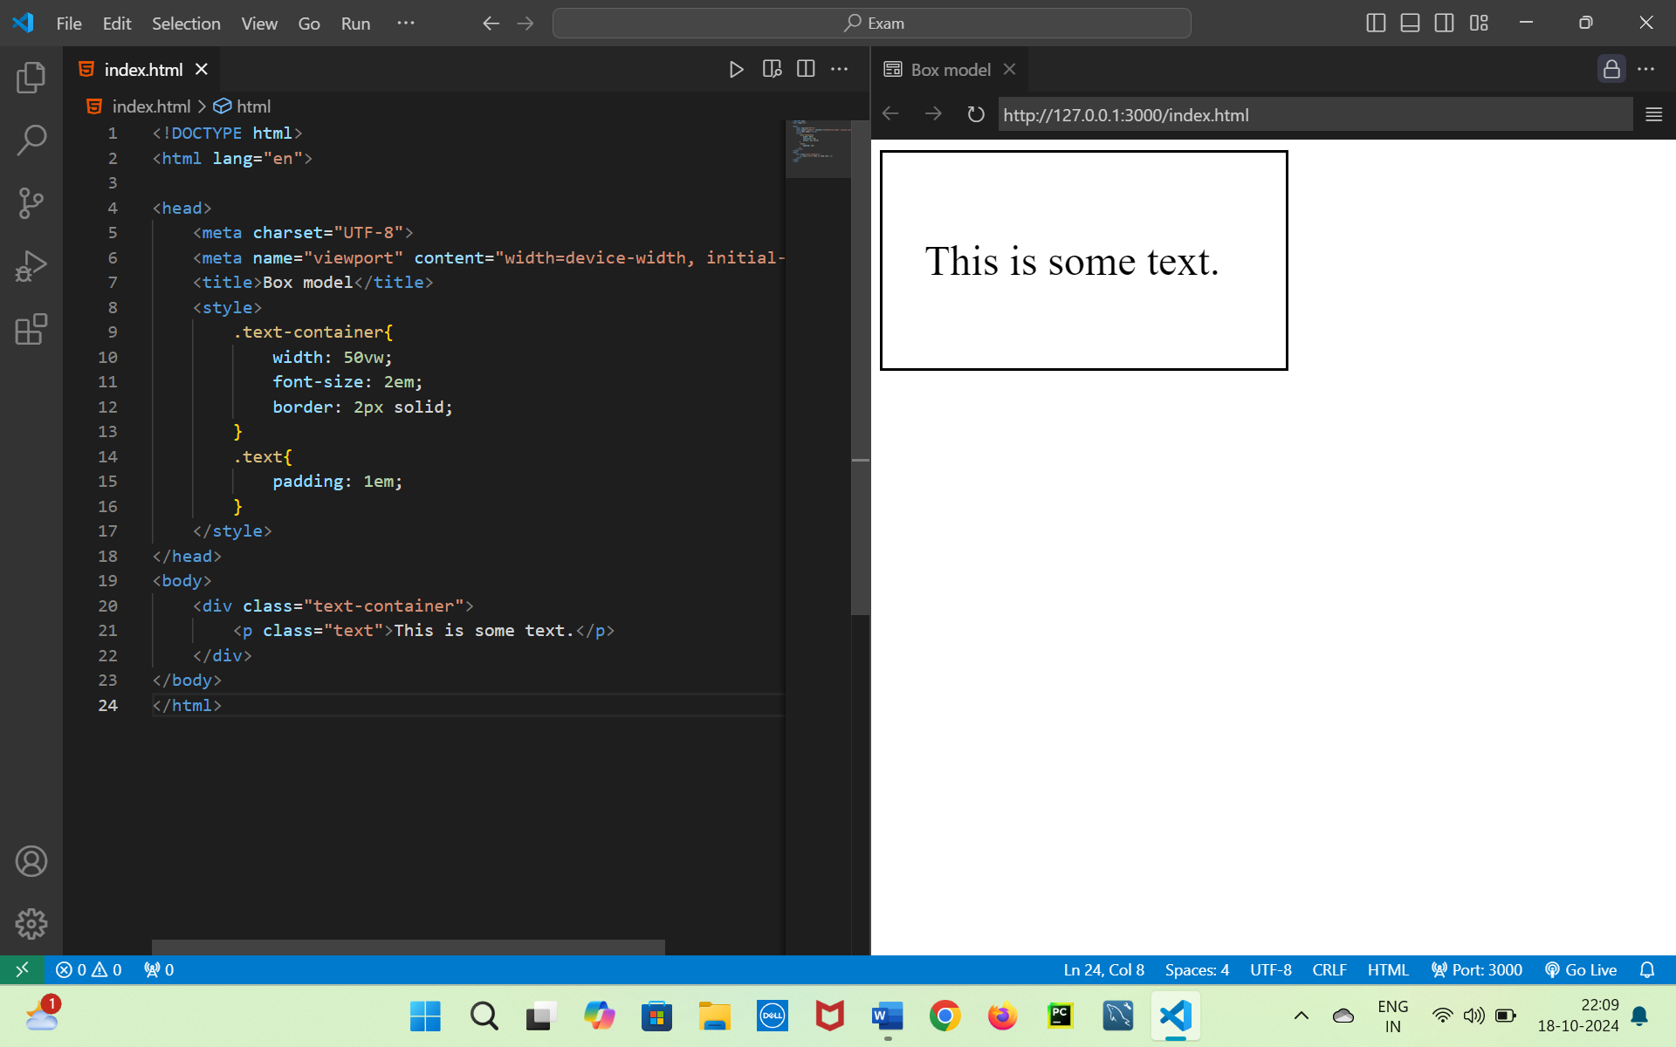

### 21. Units: Viewport Units

**HTML:**

<div class="header">  
 <h1>Welcome to My Website</h1>  
</div>

**Question:** Write the CSS to: - Set the height of the header to 50vh. - Add padding of 5vw to the header. - Center the text horizontally and vertically inside the header.

    <style>

        .header{

            border: 2px solid;

            height: 50vh;

            padding: 5vw;

            display: flex;

            justify-content: center;

            align-items: center;

        }

    </style>

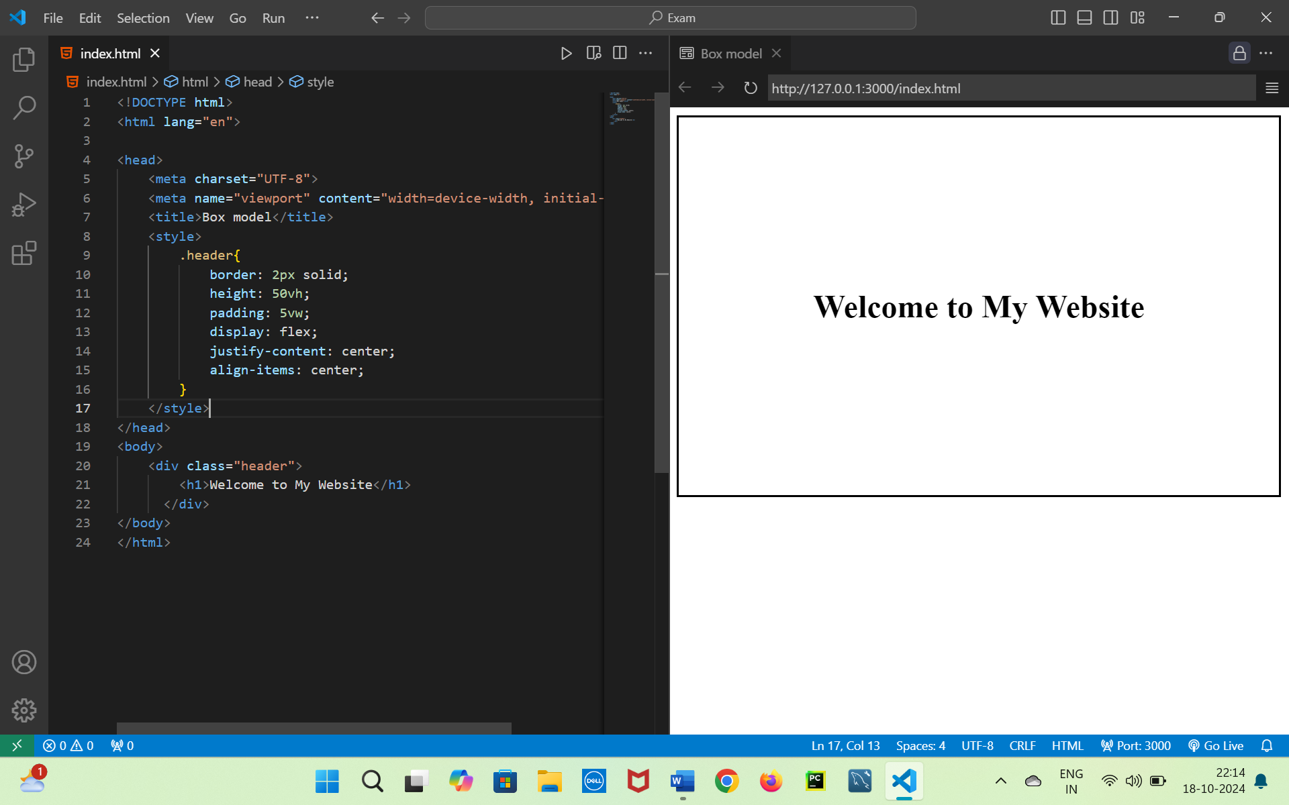

### 22. Position: Fixed Header

**HTML:**

<div class="header">Fixed Header</div>  
<div class="content">  
 <p>Some long content goes here...</p>  
</div>

**Question:** Write the CSS to: - Make the .header fixed at the top of the page with a width of 100%. - Give it a height of 60px, a background color, and make the content scroll underneath it. - Add some padding inside the .content so that it doesn’t overlap with the header.

<style>

        * {

            margin: 0px;

            padding: 0px;

            box-sizing: border-box;

        }

        .header {

            width: 100%;

            height: 60px;

            padding: 20px;

            text-align: center;

            position: fixed;

            top: 0px;

            background-color: aquamarine;

        }

        .content {

            padding: 60px;

        }

    </style>

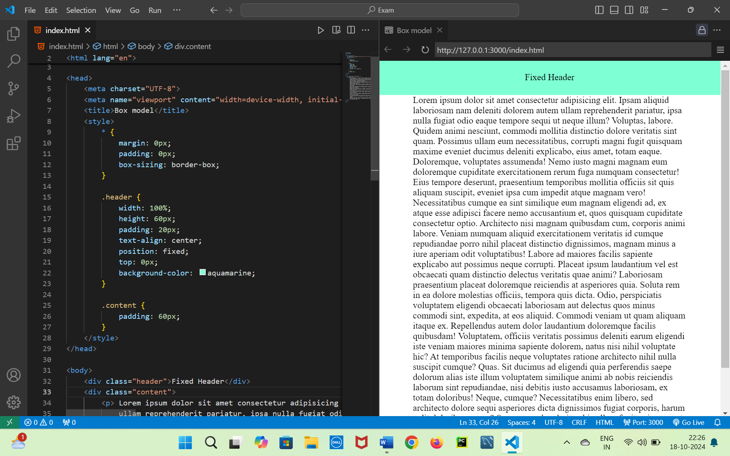

### 23. Position: Absolute and Relative

**HTML:**

<div class="container">  
 <div class="relative-box">Relative Box</div>  
 <div class="absolute-box">Absolute Box</div>  
</div>

**Question:** Write the CSS to: - Make the .container 400px by 400px with a border. - Position .relative-box relatively with a top offset of 20px and left offset of 20px. - Position .absolute-box absolutely at the bottom-right corner of .container.

    <style>

        * {

            margin: 0px;

            padding: 0px;

            box-sizing: border-box;

        }

        .container{

            height: 400px;

            width: 400px;

            border: 2px solid;

            margin: 20px;

            position: relative;

        }

        .relative-box{

            height: 100px;

            width: 100px;

            border: 2px solid;

            position: relative;

            top: 20px;

            left: 20px;

        }

        .absolute-box{

            height: 100px;

            width: 100px;

            border: 2px solid;

            position:absolute;

            bottom: 0px;

            right: 0px;

        }

    </style>

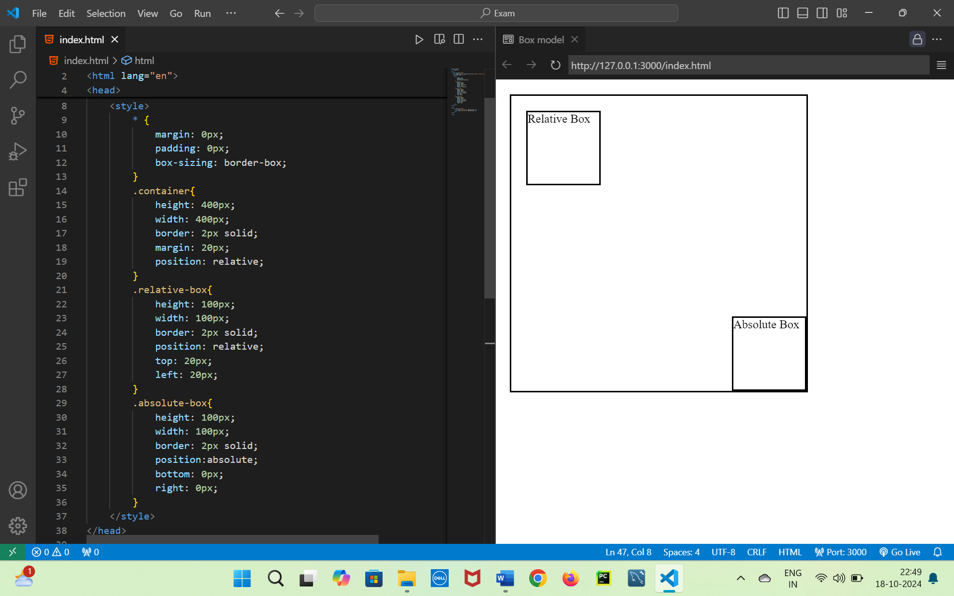

### 24. Flexbox: Centering with Flex

**HTML:**

<div class="flex-container">  
 <div class="box">Box 1</div>  
 <div class="box">Box 2</div>  
 <div class="box">Box 3</div>  
</div>

**Question:** Write the CSS to: - Apply Flexbox to .flex-container so that the .box elements are centered horizontally and vertically in the container. - The .flex-container should have a height of 300px. - Each .box should have a width of 100px and height of 100px.

<style>

        * {

            margin: 0px;

            padding: 0px;

            box-sizing: border-box;

        }

        .flex-container{

            height: 300px;

            border: 2px solid;

            display: flex;

            justify-content: center;

            align-items: center;

            gap: 10px;

        }

        .box1, .box2, .box3{

            height: 100px;

            width: 100px;

            border: 2px solid ;

        }

        .box1{

            background-color: #102030;

        }

        .box2{

            background-color: #203040;

        }

        .box3{

            background-color: #304050;

        }

    </style>

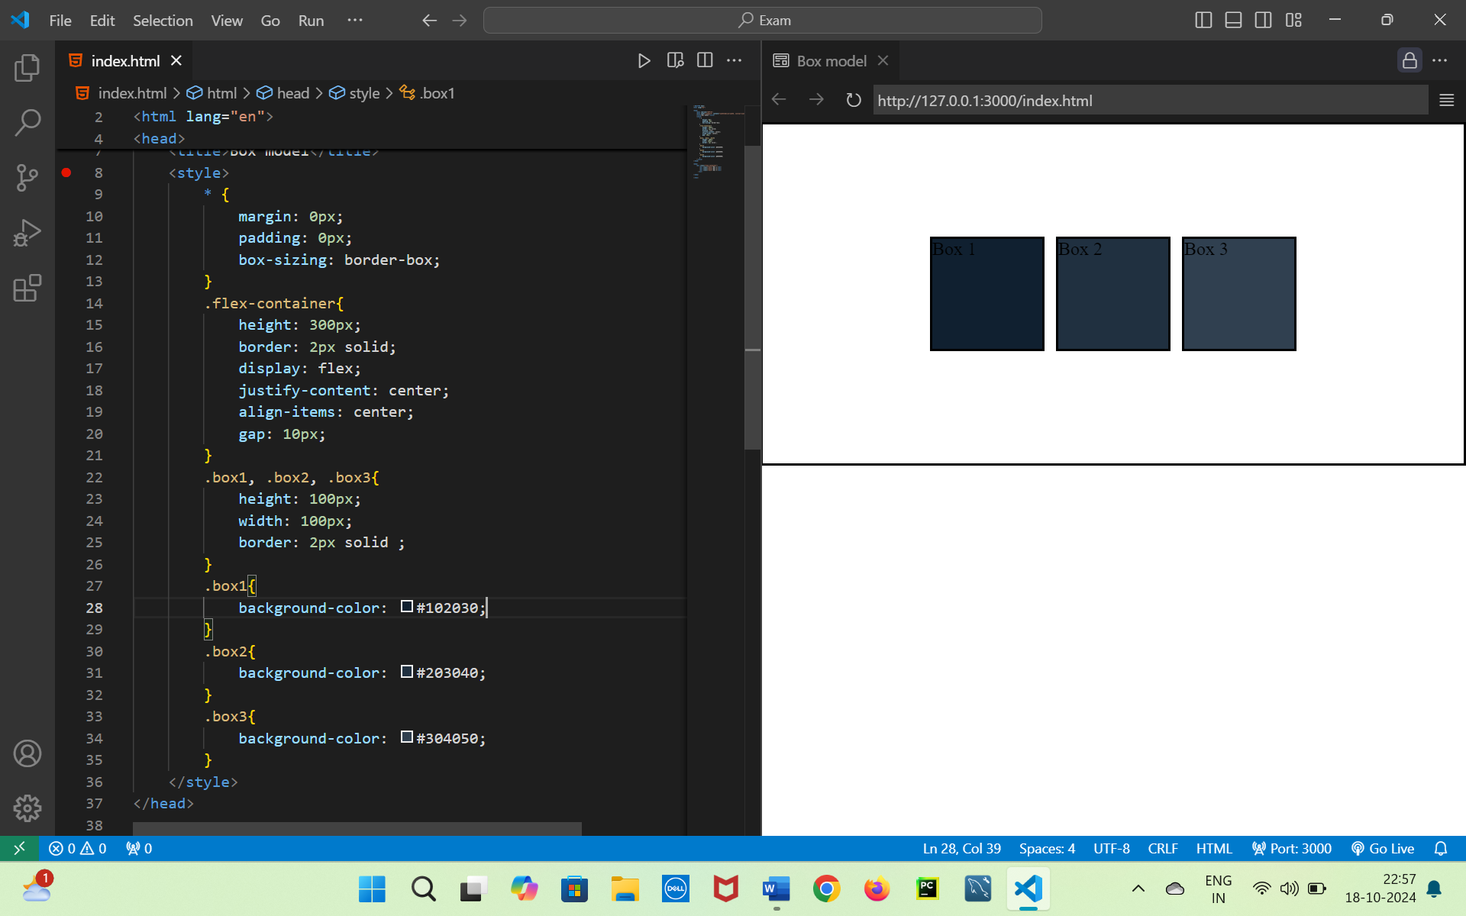

### 25. Flexbox: Space Between Items

**HTML:**

<div class="flex-container">  
 <div class="item">Item 1</div>  
 <div class="item">Item 2</div>  
 <div class="item">Item 3</div>  
</div>

**Question:** Write the CSS to: - Make the .flex-container a Flexbox container. - Space the .item elements evenly using justify-content: space-between. - Add a border around each .item and set the height of .flex-container to 200px.

    <style>

        * {

            margin: 0px;

            padding: 0px;

            box-sizing: border-box;

        }

        .flex-container{

            height: 200px;

            border: 2px solid;

            display: flex;

            justify-content: space-between;

            align-items: center;

            gap: 10px;

        }

        .item{

            border: 2px solid ;

        }

    </style>

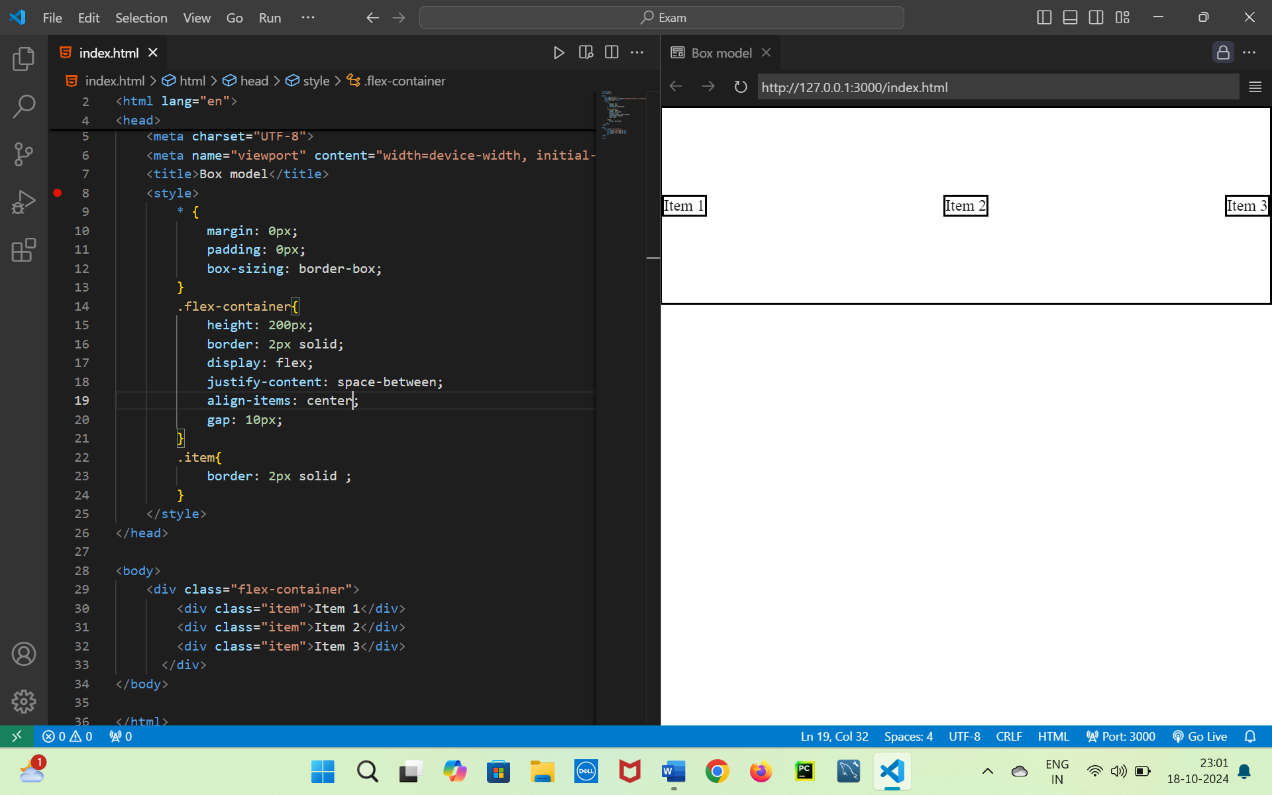

### 26. Flexbox: Column Layout

**HTML:**

<div class="flex-container">  
 <div class="box">Box 1</div>  
 <div class="box">Box 2</div>  
 <div class="box">Box 3</div>  
</div>

**Question:** Write the CSS to: - Set the .flex-container to display its .box elements in a vertical column. - Center the items horizontally within the container. - Give each .box a height of 80px and a different background color.

    <style>

        .flex-container{

            border: 2px solid;

            display: flex;

            flex-direction: column;

            align-items: center;

            gap: 10px;

        }

        .box1, .box2, .box3{

            height: 80px;

            border: 2px solid;

        }

        .box1{

            background-color: aqua;

        }

        .box2{

            background-color: aquamarine;

        }

        .box3{

            background-color: bisque;

        }

    </style>

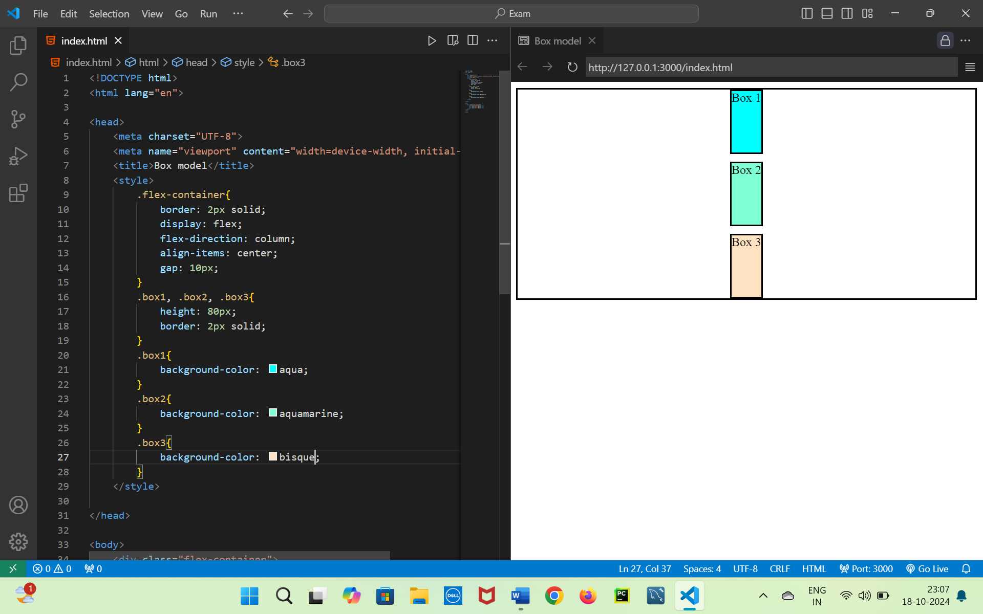

### 27. Flexbox: Wrapping Items

**HTML:**

<div class="flex-container">  
 <div class="item">Item 1</div>  
 <div class="item">Item 2</div>  
 <div class="item">Item 3</div>  
 <div class="item">Item 4</div>  
 <div class="item">Item 5</div>  
</div>

**Question:** Write the CSS to: - Make the .flex-container a Flexbox container that allows wrapping. - Ensure that the .item elements wrap onto the next line when the container is too narrow. - Set the width of each .item to 150px and the height to 100px.

    <style>

        .flex-container{

            border: 2px solid;

            display: flex;

            flex-wrap: wrap;

            gap: 10px;

        }

        .item{

            width: 150px;

            height: 100px;

            background-color: bisque;

            border: 2px solid;

        }

    </style>

